+10\*W

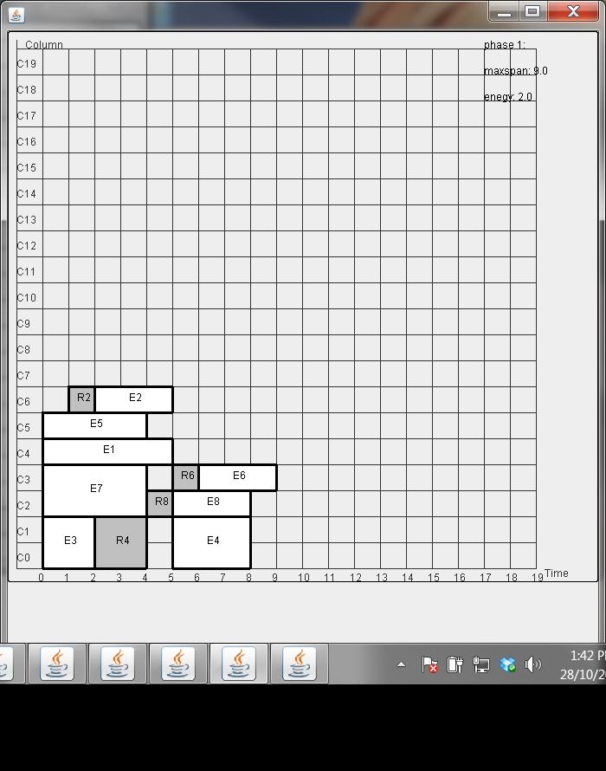

Example 2- without lk placement

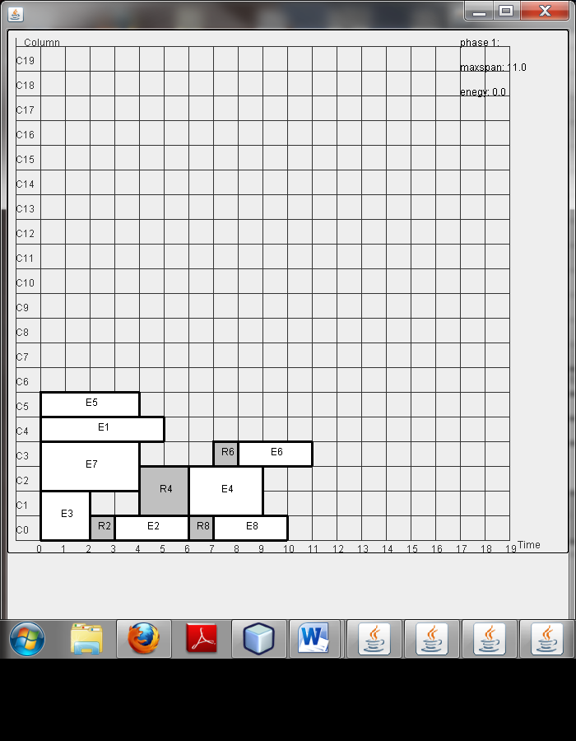

Example 2- lk=0, 20-40 ; est=20

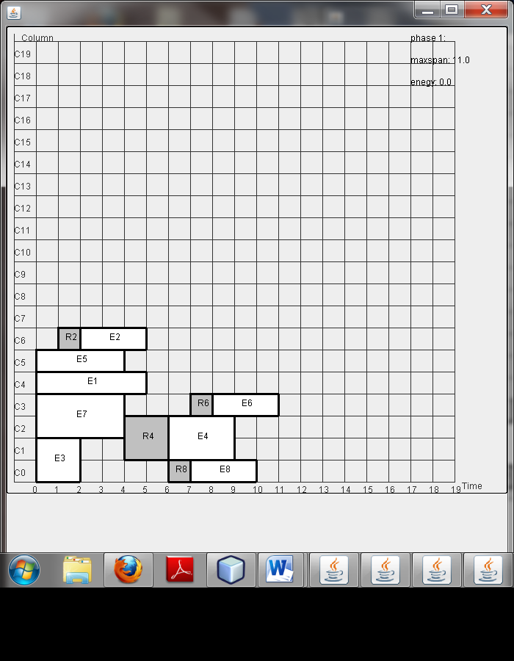

Example 2- lk=50-400 ; est=20